Call & Response 2016 Listening Guide
*To be taught PRIOR to the Cypress String Quartet visit*

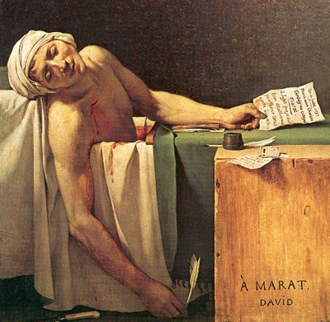

Comically Tragic: The Tragedy & Comedy in the Music of Beethoven

I. Introduction: Exploration into fundamental musical tools
a. MUSICAL EXAMPLE 1: Beethoven Symphony No. 3 ‘Eroica,’ III. Allegro vivace
b. MUSICAL EXAMPLE 2: Beethoven Symphony No. 3 ‘Eroica,’ II. Marcia Funebre—Adagio assai
c. MUSICAL EXAMPLE 3: Haydn String Quartet Op. 64 No. 5 ‘Lark,’ I. Allegro moderato
d. MUSICAL EXAMPLE 4: Bartok String Quartet No. 1, I. Lento
II. Greek Theater
a. Tragedy & Comedy of Ancient Greece (with table)
b. Art of Ancient Greece
i. IMAGE 1: “Mask of Agamemnon”
ii. Tragic Play: Agamemnon by Aeschylus
iii. IMAGE 2: Death of Cassandra (430 BC)
iv. IMAGE 8: Greek Comedic Mask (4th/3rd century BC)
v. MUSICAL EXAMPLE 5: Ancient Greek Song
III. Tragic Heroes Vs. Comedic Characters
a. Tragic Heroes
i. IMAGE 4: Batman
ii. MUSICAL EXAMPLE 6: “The Dark Knight Rises” (Main Theme) by Hans Zimmer
iii. MUSICAL EXAMPLE 7: “Superman” by John Williams
iv. IMAGE 5: Anakin Skywalker “Darth Vader”
v. MUSICAL EXAMPLE 8: “Anakin’s Theme” by John Williams
vi. MUSICAL EXAMPLE 9: “The Imperial March” (Darth Vader’s Theme) by John Williams
b. Comedic Characters
i. IMAGE 6: Captain Jack Sparrow, “Pirates of the Caribbean”
ii. MUSICAL EXAMPLE 10: “Jack Sparrow Theme” by Hans Zimmer
iii. IMAGE 7: Sheldon Cooper, “The Big Bang Theory”
iv. MUSICAL EXAMPLE 11: “The Big Bang Theory Theme” by Barenaked Ladies
IV. Beethoven – Biography
V. Beethoven: Tragedy & Comedy in his Life
a. MUSICAL EXAMPLE 12: Beethoven String Quartet Op. 130, IV. Alla danssa tedesca
b. MUSICAL EXAMPLE 13: Beethoven String Quartet Op. 130, V. Cavatina
c. IMAGE 8: The Voyager 2, NASA
d. Romeo & Juliet, by William Shakespeare
e. MUSICAL EXAMPLE 14: Beethoven String Quartet Op. 18 No. 1, II. Adagio affettuoso ed appassionato
f. MUSICAL EXAMPLE 15: Beethoven String Quartet Op. 18 No. 1, III. Scherzo: Allegro molto
g. IMAGE 9: Romeo & Juliet: The Tomb Scene, by Joseph Wright of Derby (1790)
h. Discussion Questions
i. MUSICAL EXAMPLE: 16: Prokofiev, Romeo & Juliet (Juliet’s Funeral & Death)
j. Discussion Questions
k. MUSICAL EXAMPLE 17: Beethoven String Quartet Op. 135, IV.
VI. Appendix: A further examination of tragedy & comedy through art, poem, and music
a. Tragedy
. i. MUSICAL EXAMPLE 18: Dimitri Shostakovich, Lady Macbeth of Mzensk, Katrina Izmailova’s Aria
ii. IMAGE 10: Orphan Girl at the Cemetery, by Eugène Delacroix
iii. Song of the River, Louise Glück
iv. MUSICAL EXAMPLE 19: quartetto ricercare, I. Fierce, obsessed by Dan Coleman (Dedicated to the Cypress String Quartet)
b. Comedy
i. MUSICAL EXAMPLE 20: Beatles, “I am the Walrus”
ii. MUSICAL EXAMPLE 21: Haydn String Quartet, Op. 33 No. 2, IV. Presto

Call & Response 2016

“Call & Response” was born out of the Cypress String Quartet’s commitment to presenting music as a dynamic and ongoing process of inspiration. The term “Call & Response” is usually associated with Jazz and Gospel music, with the idea being that a musician places a musical “call” to which another musician “responds.” In this program the call is that of the Cypress String Quartet searching for connections across musical, historical, and social boundaries. The response is the creation of a new work by a contemporary composer and the creation of a new and diverse concert audience.

Following over two-dozen educational outreach presentations before students of all levels and communities, the Cypress Quartet performs the Call & Response concert at Herbst Theatre in San Francisco. Scholarship tickets permit participating students to attend the public performance free of charge.

This year for the 17th Annual and Final Call & Response, the theme is “Tragedy & Comedy” and we will explore the world of Beethoven and the works that take us on a journey through the darkest emotions to the most uplifting. The 2016 Final C&R program features the World Premiere of a new work for string quartet by American composer, Dan Coleman. Coleman was the first composer the CSQ commissioned for this award-winning program in 2000, and it is fitting that he should be writing for the final C&R concert. In this spirit, Coleman’s piece will be framed by Beethoven’s first and last string quartets, Op. 18 No. 1 & Op. 135. In Beethoven’s Op. 18 No. 1, he finds inspiration in the tomb scene of Romeo & Juliet recreating this classic story. In his very last quartet we are presented with the great paradox of his Op. 135 that presents both comedic & tragic implications. Affected deeply by personal events, relationships, and world events, we will see how Beethoven’s often tragic life can often be turned into an expression of the greatest joy.

This listening guide is an aid to understanding how certain fundamental musical techniques become the palette for these composers to create sounds, colors, and moods that both revolutionary and uniquely theirs. In order to fully explore these techniques, the students will discover how specific harmonies, articulations, tempos, dynamics, musical balance, and timbre affect musical character; grasp their application; and understand how these musical techniques affect the composition’s bigger picture.

By integrating the new with the familiar, “Call & Response” explores how contemporary music is an evolution of older works. The outreach presentations, pre-concert lectures, and other activities that surround the series bring music into the community and help audiences to understand the creative process. Through Call & Response, the Cypress String Quartet is creating a public forum where a broad group of people comes together and shares in the universal experience of music.

I. INTRODUCTION: Exploration into fundamental musical tools

Note: Although most students have a background in music, this introduction is intended not only to review certain musical fundamentals, but also apply them to chamber music and the composers being discussed, thereby expanding the students’ view of composers’ use of techniques and repertoire.

In music, the word character can be defined as the kind of feeling and mood you get when listening to a composition. The composer or song-artist uses many techniques to get this feeling across including the following:

- Tempo: The speed at which music is performed
- Dynamics: The loudness or softness of a composition, also known as volume level
- Harmony: The combination of notes sounded together to create chords
  - Major: Notes together that give a happier quality to the harmony
    - MUSICAL EXAMPLE 1: Beethoven Symphony No. 3 ‘Eroica’ 3rd movement
  - Minor: A series of notes including more half-steps than Major and often sounding more sad, scary, or gloomy
    - MUSICAL EXAMPLE 2: Beethoven Symphony No. 3 ‘Eroica’ 2nd movement
  - Dissonant: Two or more notes played together that clash with one another causing jarring, and grating sounds
- Timbre: The quality of sound (ex. Rich & lush sound, warm, piercing, soft, etc.)
- Articulation: Directions to a performer that indicate the attack of a given note (short, long, connected, etc.)
  - Staccato: A style of playing notes short, detached, and separated
    - MUSICAL EXAMPLE 3: Haydn String Quartet Op. 64 No. 5 ‘Lark’ I. Allegro moderato (first 30 seconds)
  - Legato: Notes performed in a connected and smooth style
    - MUSICAL EXAMPLE 4: Bartok String Quartet No. 1, I. Lento
- Balance: Music is performed in a way that each part maintains its general importance within the musical passage (ex. Depending on who has the melody line, sometimes more bass/sometimes more treble; or sometimes more melody and less background harmony).
- Texture: How the melodic, rhythmic, and harmonic materials are combined in a composition, contributing to the overall sound and character of the piece.
- Motive: a leading phrase or figure that is reproduced and varied through the course of a composition or movement.

II. GREEK THEATER
a. Tragedy & Comedy of Ancient Greece
During the flourishing society of Ancient Greece, theater became a cultural staple and an integral part of its cultural identity. In the city-state of Athens, where cultural, political, and military power flourished, theater became the central event of the Festival of Dionysus in honor of the Greek God, Dionysia. The three pillars of Greek theater emerged at this festival: tragedy, comedy, and the satyr play. Athens exported the festival to its numerous colonies and allies in order to promote a common cultural identity.

Greek comedy was performed across ancient Greece from the 6th century BCE. The precise origin of Greek comedy is fuzzy, but the first indication of comic material are displayed on pottery where images among this time often depicted actors dressed as horses, satyrs, and dancers in exaggerated costumes. The famous playwrights of this genre were Aristophanes and Menander, their works poking fun at politicians, philosophers, and fellow artists. This form of theater gives insight into the Greek society at the time, providing details of political institutions, legal systems, religious practices, education, and warfare.

Coupled with comedy, Greek tragedy helped lay the foundation upon which all modern theater is based. Of the surviving Greek tragedies, all but a few draw their story from heroic myths. Tragedy emerged in the 5th century BC with the contributions of three well-known playwrights, Sophocles, Euripides, Aeschylus, and the first recorded actor, Thespis. Until the Hellenistic centuries later, all tragedies were played only once in honor of Dionysus and so their legacy lives only from records of those that remembered it well enough to have been documented when the repetition of old tragedies became popular.

Tragedy | Comedy
Emphasizes human suffering | Emphasizes renewal of human nature
Ends with rigid finality | Moves from rigidity to freedom
Moves with solemnity and foreboding | Plays with prevailing high spirits
Emotional response (pity & fear) | Intellectual response (ridicule and absurdity)
Identification with hero | Scorn/approval of protagonist/others
Laments man’s fate | Celebrates life
Criticizes self-delusion and complacency | Criticizes folly, self-delusion, and complacency
Offers some hope (man can learn), but stresses limitations of the human condition | Suggest cynicism (man a fool), but offers hope of renewal

b. Art of Ancient Greece:

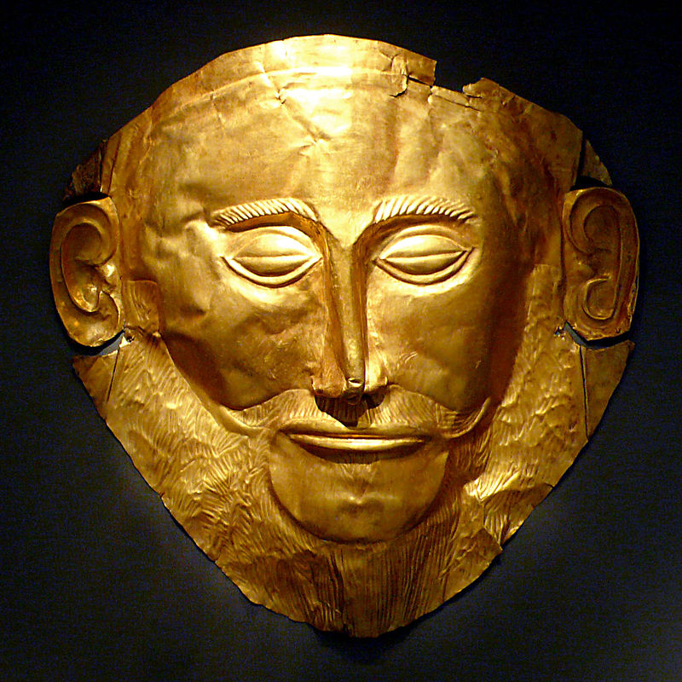

IMAGE 1: “Mask of Agamemnon”
The Mask of Agamemnon is one of the most famous works of art in history. Heinrich Schliemann found it in a tomb in Myenae in 1876. Myenae is now an archaeological site in Greece, but in the second millennium BC, was one of the major centers of Greek civilization.

Tragic Play: Agamemnon by Aeschylus
Agamemnon was a play within a trilogy of Greek tragedies known as the Oresteia by Aeschylus. This play tells the story of Agamemnon coming home after the Trojan War. His wife, Clytemnestra, has been waiting at home for him, but has been planning his murder out of revenge for the sacrifice of their daughter, Iphigenia, and because she has been having an affair with Aegisthus, Agamemnon’s cousin. She eventually kills Agamemnon in the bath.

The character Cassandra enters in a trance. In this mad scene, she enters in an incoherent delirium, eventually forming nouns and adjectives that make sense. She begins with a discussion about whether she should enter the palace, knowing if she does, she too will be murdered. Apollo curses her, giving her the ability to foresee future events, but the curse being no one will believe her prophecies. Because of this, her family and the Trojan people consider her a liar and a madwoman. She eventually enters the palace after realizing her fate of death is unavoidable.

Clytemnestra kills both Agamemnon and Cassandra. The chorus ends by reminding us that Orestes, the son of Agamemnon, will have vengeance in the future.
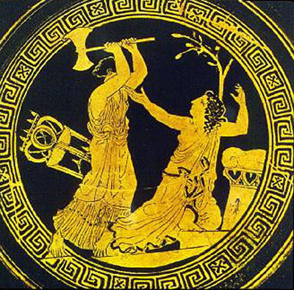

IMAGE 2: Death of Cassandra (430 BC)

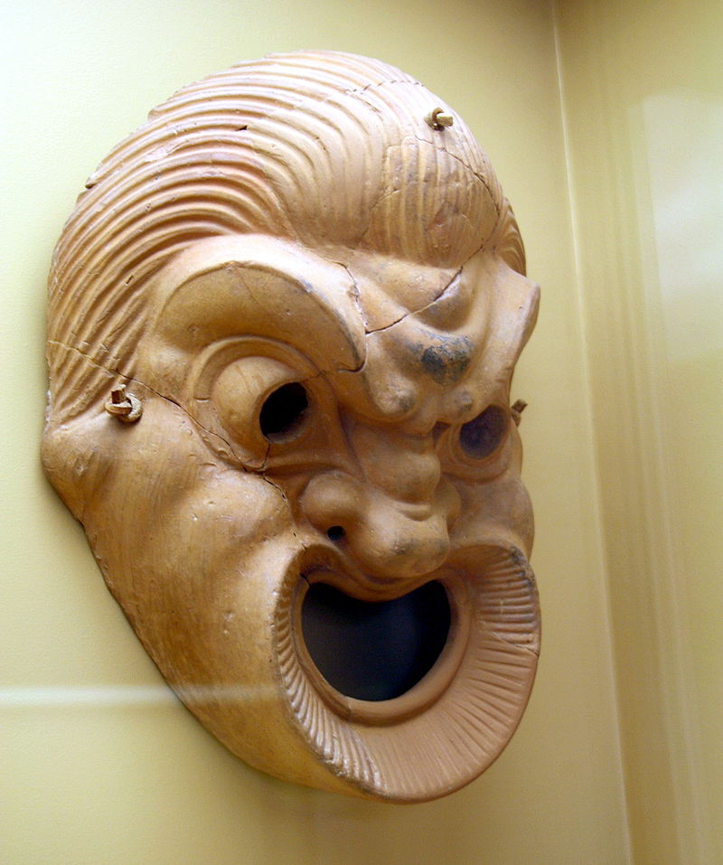

IMAGE 3: Greek Comedic Mask (4th/3rd century BC)
Masks served many important purposes in the Ancient Greek Theatre. Most masks hold exaggerated expressions that not only help define the characters, but helped audience members in distant seats see. In a tragedy, masks were more life-like, but for comedic plays, masks were often ugly and grotesque (as seen above).

Musical Example 5: Ancient Greek song
This song was originally found on stone inscriptions from ancient Greece on an eight-string “canon” instrument. Dr. Armand D’Angour, a musician and teacher at Oxford University, studies ancient Greek music in depth and this song is a close transcription of what this music may have sounded like. He states “it is often forgotten that the writings at the root of Western literature – the epics of Homer, the love-poems of Sappho, the tragedies of Sophocles and Euripides – were all, originally music.” The music differed quite greatly from Western music, with the use of different pitch and scale-tunings, and different rhythmical and melodic norms. The great ancient poet-singer, Homer (author of the Iliad and Odyssey), tells us that the bards during his time sang to a four-stringed lyre and those strings were probably tuned to the four notes that were at the core of the later Greek scale systems, sung with a monotone melody on top.

III. TRAGIC HEROES VS. COMEDIC CHARACTERS

a. TRAGIC HEROES: A character that makes a judgment error that inevitably leads to his/her own destruction. Characteristics of a tragic hero include:
- Flaw or error in judgment that leads to downfall
- A reversal of fortune brought about by the character’s error in judgment. Character usually falls from noble status or stature.
- Personally responsible for own wrongdoings
- The character’s fate is usually worse than deserved

IMAGE 4: Batman
“He’s the hero Gotham deserves, but not the one it needs right now. So we’ll hunt him. Because he can take it. Because he’s not our hero. He’s a silent guardian, a watchful protector. A dark knight.”
–Lt. James Gordon, Dark Knight

Bruce Wayne was born in the city of Gotham, into a wealthy family. After witnessing the murder of his parents as a child, he swears to get his vengeance by fighting criminals. He is trained physically and intellectually and uses bats to symbolize his persona, becoming Batman. Unlike most superheroes, Batman possesses no superpowers and relies on his intellect, physical prowess, martial arts abilities, detective skills, wealth, ability to invoke fear in criminals, and passion to fight for the good of Gotham. Unlike heroes such as Superman, Batman is not always an obvious hero in his society. Batman becomes a vigilante symbol to Gotham, going against the organized crime-fighting force that has been failing the city for years. His goal of saving Gotham from collapsing and avenging his parents never falters, even if that means the symbol of Batman must be destroyed. He realizes that in the end, what the city needs is an exemplary citizen who fights for good, not a flawed vigilante. And so, Batman sacrifices his reputation for the good of Gotham, saving the symbol of Harvey Dent as the “white knight,” a symbol that could alone turn around the collapsing Gotham.

Musical Example 6: “The Dark Knight Rises” (Main Theme) by Hans Zimmer
- How does this music depict Batman as a “dark knight”? What kind of harmony is used to depict this? How does the rhythm and tempo affect this depiction?
The key of this is kept in minor, the rhythms drive, and often the mood is “dark.” (the dark mood depicted through the constant low registers in percussion and bass instruments).
- What musical tools does the composer use to depict Batman as a hero? Notice the instrumentation for melodies, and how the melodies develop
Often the melodies that blossom are played with horns, giving the melody a more noble timbre. Often the melodies take us into moments of Major keys.

Musical Example 7: “Superman” by John Williams
Batman was a symbol that struck fear into the hearts of criminals, but because of his need for vengeance, he was not always seen as a symbol for good. Superman, however, was undeniably a symbol for justice and truth. He was an unmasked hero, with a suit of bright blue, red, and yellow, with unending strength, speed, stamina, endurance, and healing. He was a beacon of light.
- How is the theme to Superman different than Batman? Listen for harmony, instrumentation, mood, etc.
This theme has a consistent major key. The main melody stays in the horns, mainly trumpets (brass often used to depict nobility), and is often answered with bright “sparkling” chords in the orchestra. John Williams uses flourishes of flutes, chimes, and treble sounding instruments to add to the bright sound.
- What musical tools does the composer use to depict the music of a hero? What kind of rhythm does he use? What is the tempo?
After the introduction, there is a consistent “marching” beat and rhythm in the bass instruments. The tempo is fairly up-beat and forwarding moving, giving it the drive of Superman.
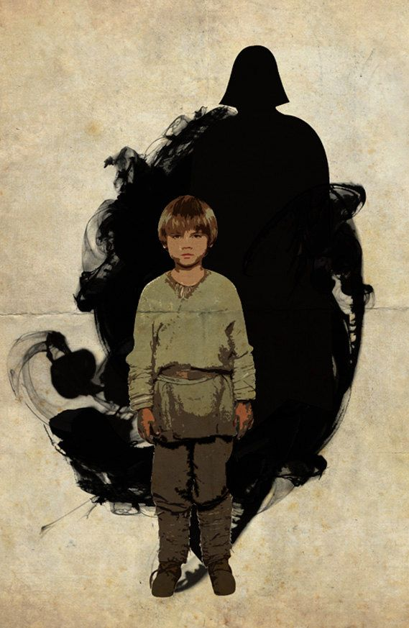

IMAGE 5: Anakin Skywalker “Darth Vader”

“Fear is the path to the dark side” –Yoda
Anakin Skywalker is a young slave boy from the desert world of Tatooine. He is a born with great virtue, always seeking to help make the universe a better place. Upon being discovered by Jedi Qui-Gon Jinn that Skywalker has a strong natural feeling of the Force, he has the chance to leave his forsaken homeland to train to become a Jedi Knight. With his strong natural Force ability, it is quite apparent that Skywalker is destined to become one of the most powerful and influential figures in the galaxy. It is said that the Jedi Council believed Skywalker is the Chosen One of Jedi prophecy and will bring balance to the Force by destroying the Sith Order. When the Clone Wars began, Skywalker fears for the safety of his mentor, Obi-Wan Kenobi, his wife, Padme Amidala, and clone troopers placed under his command. During these wars, the Jedi community recognized his fear and anger as potentially serious flaws, flaws that will indeed push him to the “dark side of the Force.” Once on the dark side fighting for the Sith Lord, Anakin Skywalker sheds his name, becoming Darth Vader, one of the most powerful beings in the universe and the embodiment of evil & corruption. At the end of Vader’s life, he is defeated in an epic duel with his son Luke Skywalker. His son refuses to kill him, and moved by Luke’s love, Vader abandons the dark side, sacrificing himself to destroy the Emperor, fulfilling his purpose of the Jedi prophecy.

Music Example 8: “Anakin’s Theme” by John Williams
- What kind of harmony does this piece use? How does it depict Anakin as a boy?
Major key, very hopeful and innocent.
- What kind of articulation is used most often?
Very lyrical passages

Musical Example 9: “The Imperial March” (Darth Vader’s Theme) by John Williams
- What kind of harmony does this piece use? How does it help depict Darth Vader?
Very minor, Anakin has turned dark.
- What kind of articulation is used? How does this impact the picture John Williams paints of Darth Vader?
- What is the instrumentation used? What is the role of the instruments?
Strings are often scurrying, while brass play an articulated motive.

b. COMEDIC CHARACTERS
Ancient Greek comedy was one of three principal dramatic forms in the theater, the others being tragedy and the satyr play. What came to be known as Athenian Comedy, was divided into three periods, Old Comedy, Middle Comedy, and New Comedy. Old Comedy was known for its satire of public figures and affairs, its slapstick absurdity, and frequent use of heroes and gods as subjects. Middle Comedy transitioned into more general concepts of ridicule, focusing on philosophical, political, and literary subjects. Finally, New Comedy emerged, resembling much of the comedy we have today that includes situational comedy (as seen in sitcoms, hence situational comedies) and the comedy of manners that includes stereotypical stock characters.

IMAGE 6: Captain Jack Sparrow
“The problem is not the problem. The problem is your attitude about the problem. Do you understand?
–Captain Jack Sparrow

Captain Jack Sparrow is a pirate in the Pirates of the Caribbean films. He is seen throughout the story fleeing situations only by a thread, using wit and negotiation to get himself out of danger. “Why fight when you can negotiate?” He uses non-violence to obtain what he wants most in life: the Black-Pearl (his beloved ship) and freedom. He is able to use his witty intellect to turn enemies against each other and even tempt enemies away from their murderous intentions, shining light on the bigger picture. However morally ambiguous his character might be throughout the films, through his ridiculousness, wit, and good influence, we find a character that is easy to laugh with.

Musical Example 10: “Jack Sparrow Theme” by Hans Zimmer
- How does this music depict Jack Sparrow’s character? Notice how the composer uses, rhythm, stylistic tools, articulation, etc.
There is a constant bass rhythm, however the composer uses a constant “long-short” articulation to keep it a bit off kilter. The melody in the cello has an off kilter rhythm as well, but also incorporates slides in the melody to give it more freedom and wit.
- How does the timbre of the piece give us the picture of a pirate?
Usually low timbre, very low bass starts the rhythm on the bottom, and the cello is the main melody. Pirates have never easily been seen as the good guy, and this low timbre gives the audience a darker picture of this comedic character.

IMAGE 7: Sheldon Cooper, “The Big Bang Theory”

“Love is in the air? Wrong. Nitrogen, Oxygen, Argon, and Carbon Dioxide are in the air”
-Sheldon Cooper, The Big Bang Theory

Sheldon Cooper is a character portrayed by Jim Parsons on the TV show, The Big Bang Theory. Sheldon is a senior theoretical physicist at Caltech. He is a former child prodigy, with a genius level IQ, but lacks almost all social skills. He is proudly geeky, with no shame in speaking Klingon (a fictional language found in Star Trek), wearing t-shirts sporting superhero logos, or voicing his detailed knowledge on various historical and culture anecdotes. In the show, Sheldon is portrayed with a strict adherence to hygiene, an overly intellectual personality, minimal understanding of irony, sarcasm, or humor, and a general lack of humility or empathy. With these qualities along with an interest in pranks, Sheldon makes for one funny, quirky guy.

The Big Bang Theory is a prime example of how our own comedy has been influenced by the New Comedy (a situational comedy that includes stereotypical stock characters) of Greek Theater.

Musical Example 11: “The Big Bang Theory Theme Song” by Barenaked Ladies
- Why do you think this song was chosen as the theme song to The Big Bang Theory? Without knowing the lyrics, is this funny?
This song starts slow and then gets faster and faster as it goes along. There is the inclusion of humor in the random sounds that interrupt the song. We hear little “dings”, the sound of scratching records, and random insertions of people screaming “HEY!”
- What are some musical tools this song uses? Harmony, dynamics, tempo, character, etc.
This theme song is in a major key. The song begins with softer dynamics and a slower tempo, gradually increasing both as it progresses. The character and mood is very uplifting and positive, setting up a sitcom that is fast paced and humorous.

IV. BEETHOVEN

Ludwig van Beethoven (1770-1827) was a German composer and is one of the most influential figures in music. He displayed his talent for music at a very young age, moving to Vienna in 1792 to study with Haydn and perform the keyboard. By the last decade of his life, he had become almost completely deaf, but continued composing what some will argue are his ultimate masterpieces.

Beethoven was an important figure in the transition from the Classical era of music into the Romantic. His music has been categorized into early, middle, and late periods. In his early period, Beethoven wrote six quartets that are a part of the Op. 18 quartets and act as a tip-of-the-hat to both Haydn and Mozart. The middle period was distinctly marked by his general unhappiness with his previous compositions and his desire to compose in a new way that belonged to a different world of feeling and thought.

In the years 1800-1806, Beethoven reached a powerful juncture in his life, experiencing great despair, but finding inspiration to prevail. For him the turn of the century was marked by an attempt to end his life. His heart was broken, and his increasing deafness was isolating him more and more from the world around him. However, after the onset of the French Revolution and Napoleonic Wars, Beethoven gained inspiration and enthusiasm for freedom and the power of art, and he began writing what are known as his Middle Quartets. During this time he felt the greatest happiness. He began writing the quartets free of formal tradition, with melodies that were wholly Beethoven.

During the last three years of his life, while Beethoven was suffering from severe health complications, emotional distress, and deafness, he wrote what are known as his Late Quartets. In this time, his brother died, one of his most supportive patrons died, and he was spun into a deep financial hole. Sadly, another of his brothers decided to take advantage of this financial distress. He writes in a letter, “My situation is so critical that I can no longer keep my eyes fixed on the stars.” However, through all of this hardship, he was able to write his late quartets, which showcase his most intimate and expressive works of inner spirit.
V. BEETHOVEN, TRAGEDY & COMEDY OF HIS LIFE

Beethoven had a very trying life, experiencing extreme physical, emotional, and financial hardships. In a document known as the Heiligenstadt Testament, he wrote to his brothers Carl and Johann at Heiligenstadt (now a modern part of Vienna) on October 6, 1802. The letter expresses his distress over his increasing deafness, leading him to isolate himself from society. His despair became so overpowering that he considered ending his life, but his art was the fuel that kept him going. He expressed that he felt it impossible to leave a world without first bringing forth all that was felt within him. Beethoven was one of the greatest composers with some of the greatest hardships and although one would expect an outpouring of constant sorrow, the world was left with many masterpieces that give great hope.

For Beethoven, it seems moments of tragedy are often best paired with comedy. With his clever and innovative skills of composition, Beethoven is able to create music that can make fun of itself, in a way that is often unexpected or even grotesquely humorous.

In Beethoven’s String Quartet in B flat Major, Op. 130, he creates a work of caricatures, each contrasting movement strung together by taking us through varying human expressions. As listeners, we are taken through a journey of characters and masks. In this work, his pairing of the different ‘caricatures,’ contrast in a way that listeners might find themselves burst out laughing, and then crying within moments.

Musical Example 12: Beethoven String Quartet Op. 130, IV. Alla danssa tedesca (“in the style of a German dance”)
This movement is a wonderful example of Beethoven’s wit. It is a kind of waltz, and acts as a parody of rustic and, what might be considered, “unsophisticated” style music. Beethoven plays games, using unexpected and “unfitting” rhythms, then finding sections of an inward love that in the end is interrupted abruptly, humor prevailing.

Musical Example 13: Beethoven String Quartet Op. 130, V. Cavatina
This movement is one of Beethoven’s most famous musical achievements. The Cavatina is included on what is known as the Golden Record, a 90-minute record that includes music that represents all areas of the world and sent on the Voyager spacecraft. The Voyager is intended to be a time-capsule that represents the human race. Carl Sagan says, “the spacecraft will be encountered and the record played only if there are advanced space-faring civilizations in interstellar space (aliens who find it).” Voyager 1 has now entered what is known as interstellar space, traveling “further than anyone, or anything, in history.”
It has been said that while writing the Cavatina, Beethoven could not help from weeping. This movement explores emotions of love and vulnerability, in a way that expresses both warmth and loneliness. In the movement, there is a point where the violin is left in isolation, marking the passage “beklemmt,”roughly translating to mean, “heavy at heart”, or “oppressed.” The movement ends with warmth, uneasiness, and a look into the most inner depths of human emotions.

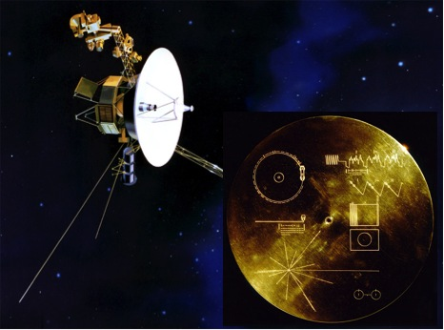

IMAGE 8: The Voyager 2, NASA. This spacecraft holds The Golden Record. The inscriptions on the record explain how to use it and play it.

Romeo & Juliet, William Shakespeare
At a ball thrown by house Capulet, a heartsick Romeo attends in the hopes of seeing his unrequited love, Rosaline. Instead he meets and falls in love with Juliet, a girl from his sworn family enemy, Capulet. Romeo sneaks into the Capulet orchard, where he and Juliet proclaim their love and decide to marry. Friar Laurence, a friar and friend recognizes their love as an opportunity to reconcile the age-old animosity that has been plaguing the Montague and Capulet families. With his help, they are married secretly the next day. Violence falls as Tybalt, Juliet’s cousin, enraged at Romeo’s attendance at the ball, decides to challenge Romeo in a duel. Romeo refuses and his friend Mercutio fights Tybalt in his place and, to the horror of Romeo, Tybalt kills Mercutio. Out of anger for Mercutio’s death, Romeo kills Tybalt and is banished by the Prince. Juliet, upon being told she will be marrying someone else, decides to take a sleeping potion and fake her death. Romeo, unaware of her plan finds her ‘dead’ and kills himself. To the horror of the reader, Juliet finally wakes up and is stricken with such sadness upon seeing Romeo dead and kills herself.

Beethoven String Quartet Op. 18 No. 1
The late 18th century proved a fruitful time of composition for Beethoven as he composed his earliest set of works for the string quartet medium, the Op. 18 Quartets. In 1792, Beethoven made a pilgrimage from Bonn to Vienna where, from the account of his friend Count Waldstein, Beethoven came to “receive the spirit of Mozart at the hands of Haydn,” Beethoven admired the character and spirit of Mozart’s works as well as the compositional techniques of Haydn. Although Beethoven’s lessons with Haydn were not a success, his early works were a nod to the sound of Haydn and Mozart, composing the Op. 18 Quartets as a six-piece set, presumably with Mozart’s six quartets dedicated to Haydn in mind.

The Op. 18 quartets were put into a specific order by Beethoven, but did not follow the order of composition. He composed Op. 18 No.1 between 1798-1800 and, as seen from the sketches, was actually written after his Op. 18 No. 3. It was not uncommon for Beethoven to create several sketches for works, but this work was unique in that it can be examined as two complete versions, the first being sent as a gift to his friend Karl Amenda. Within a few weeks of handing off the first version, he asked his friend Karl to show the work to no one, as he felt that in the meantime he had truly learned how to write a string quartet.

MUSICAL EXAMPLE 14: Beethoven String Quartet Op. 18 No. 1, II. Adagio affettuoso ed appassionato
The Adagio second movement provides the foil for the brilliance of the first movement. According to Beethoven’s letters with Amenda, he took inspiration for this movement from the tomb scene of Shakespeare’s Romeo and Juliet. He takes us into the melancholy of D-minor, expressing melodies of deep longing in conversation, often punctuated with dynamic mountains and valleys along with silences. Long melodies eventually result in the last romantic statement from the cello, answered by the violin in a last attempt of hope, as the movement cascades into darkness.

Listen for
- Use of harmony: What kind of harmonies dominates the beginning? How does he take us out of the major keys? How does this affect the mood?
Begins with minor harmonies. In the middle of the movement, it explores uplifting major harmonies, only to be interrupted by a dramatic descent into minor.
- How does Beethoven use musical texture to affect the mood of the movement? Listen for the rhythms underneath melodies, dynamics, unisons, and passing material.
In the beginning, the cello, viola, and 2nd violin come in with walking 8th notes. Mixed with the harmony, this walking rhythm gives us a feeling of progressing to a funeral. Later in the movement, Beethoven uses this same walking 8th note motive, but starts using it in forte exclamations. In contrast, Beethoven uses lyrical and flowing rhythms passed from voice to voice, possibly representing a loving emotion.
- This movement is preceded a lovely and charming 1st movement. If a darker movement preceded the Adagio, would it have the same affect? How would it change?

MUSICAL EXAMPLE 15: Beethoven String Quartet Op. 18 No. 1, III. Scherzo: Allegro molto

Beethoven swiftly leads us from this gloomy darkness into a witty scherzo (the word scherzo literally meaning “joke”), similar to those that are found in Haydn’s later quartets. However inspired Beethoven was by Haydn, his personality is prevalent, beginning his phrase structure with a unique stitching of 6 + 2 + 2, dispersing asymmetry and symmetry in a way that almost foreshadows material and technique he uses in his later works.

Listen for:
- Use of harmony. How does the key of this movement help the contrast from the 2nd movement?
MAJOR!
- The title of this movement is Scherzo, meaning, “joke.” What techniques does Beethoven use to be witty? Notice rhythm, dynamics, tempo, and articulations.
The tempo of the Scherzo moves quite quickly (contrasting well with the 2nd movement). Beethoven changes quickly from legato to short articulations, pianos to fortes, and quick sections into complete silence. He is constantly keeping us on our toes. I’m sure he was smirking the whole time.
- If a joyous movement followed this Scherzo, would it have the same impact? How would it change?

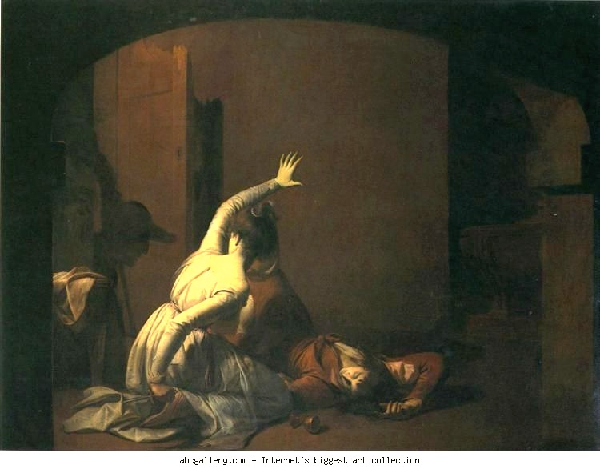

IMAGE 9: Romeo & Juliet: The Tomb Scene, Joseph Wright of Derby (1790)
In this work, Derby depicts the tomb scene in Romeo & Juliet, at the point where Juliet, kneeling by Romeo’s body, hears footsteps and draws Romeo’s dagger. She exclaims, “Yea, noise? Then I’ll be brief. O happy dagger!” just before Juliet kills herself.

Discussion Questions: What is the general tone that is depicted in this painting? How does the artist use light and darkness, and how does that help with the work’s message and impact?
Joseph Wright Derby was famous for his skills in depicting nocturnal & candlelit scenes. The dark and dull colors depict the dark tomb and also depict the tragic tone. The light shines on Juliet, an innocent life lost for a tragic cause.

MUSICAL EXAMPLE 16: Prokofiev Romeo & Juliet, (Juliet’s Funeral & Death)
In comparison to Beethoven’s interpretation of the tomb scene in Romeo & Juliet:
Around 1934 composer Sergei Prokofiev received a commission for a full-length ballet from Kirov Theater and it was decided that Shakespeare’s “Romeo and Juliet” would be the subject. The road to its performance was not easy, as the Kirov Ballet backed out of the project unexpectedly, being taken over by the Bolshio Theater. In 1938 the Bolshoi Ballet pronounced Prokofiev’s music “unsuitable to dance” and dropped out as well. Finally, the premiere of “Romeo and Juliet” was given in Brno, Czechoslovakia without Prokofiev’s participation. The pressure of the Soviet Union under Stalin proved quite difficult for Prokofiev as there were strict rules for music, and works were often scrutinized and banned. The last scene of the “Romeo and Juliet” is a lament, a tragic march of intensity, interspersed by the lovers’ themes. This is the music that was played at Prokofiev’s funeral on a tape recorder because all of Moscow’s musicians were required at the funeral of Stalin, who died within hours of the composer.

Discussion Questions:
- Both Beethoven & Prokofiev depict the same story, but how is Prokofiev’s depiction of the tragedy of Romeo & Juliet different from Beethoven’s?
- Prokofiev used a full symphony orchestra whereas Beethoven only uses a quartet of strings. How does the orchestration affect the tone, mood, and general character of the work?
(Note how he uses strings, brass, and percussion).
- How has Prokofiev’s historical context affected the music? In what ways does his life in the Soviet Union at the turn of the century and during Stalin’s reign show?

MUSICAL EXAMPLE 17: Beethoven Op. 135, IV. Der schwer gefaßte Entschluß (The difficult decision).” Grave, ma non troppo tratto (Muss es sein?/Must it be?) – Allegro (Es muss sein!/It must be!) – Grave, ma non troppo tratto – Allegro
The last year of Beethoven’s life was difficult on every level. His health was poor, his finances were in shambles and his suspicious and distrustful nature had driven away all but a few friends. This made him cling desperately to his nephew (and adopted son) Karl. In August 1826, Karl attempted suicide, claiming later, “my uncle harassed me so.”
Amid the chaos, Beethoven composed what was to be his last Quartet, Opus 135 in F Major. His third quartet in the key of F (Op. 18, No. 1 and Op. 59, No. 1 share the key), the work was written during the two months that Karl was recovering in the hospital. Completed in October 1826, Opus 135 was written only months after Beethoven’s surprising Quartet in C-sharp minor, Opus 131. That the two share the same span of time and sprang from the same composer’s imagination is mind-boggling. After stretching the form of the quartet to its very limits in Opus 131 (which is in seven movements, played without pause), the Opus 135 Quartet is in a new style, or rather, is a return to a more classical aesthetic. The brevity and “normality” of the piece makes it stand apart from the other quartets of Beethoven’s late period. Scholars suggest that perhaps he intended Opus 135 to be the first of a new set of quartets.
For the finale movement, Beethoven provides us with a riddle as a preface. Above the music, he writes “Der Schwer gefaβte Entschluβ” (The Difficult Resolution or Decision), and gives us two short examples of music. The first is marked “Grave” and contains the question “Muβ es sein?” (Must it be?). The second is marked “Allegro” and states not once, but twice: “Es muβ sein! Es muβ sein!” (It must be! It must be!). What follows is a musical discussion, going back and forth between the two, with the answer “It Must Be!” triumphantly claiming the end. The piece comes to a close with wit and lightheartedness. Scholars have hotly debated Beethoven’s meaning of the opening question and answer, with opinions ranging from discussions of Beethoven using music to debate a range of ideas including (but not limited to): “free will versus destiny”, the laundry bill, the necessity of paying the rent, and the inevitability of death.
[notes by Jennifer Kloetzel]

Listen for:
- How does Beethoven depict “the difficult decision?” Listen for use of harmony, dynamics, balance (low and high).
Minor key. Opens with low strings followed by lyrical violin. The exclamations in between silence start forte and in unison and eventually slowly die in dynamic.
- How do the moments of silence in the intro make you feel?
Beethoven is a master at creating tense silences. Here, the uneasiness and harmonic tension is carried into the silence.
- What happens after the introduction material? How do harmony, rhythmic motion, and tempo change? How does this affect the character?
Harmony turns major. There is more motion in the rhythm and the tempo increases. He leaves us one the last note in a joyous mood, a happy ending for the quartet works of Beethoven
VI. APPENDIX : A FURTHER EXAMINATION OF TRAGEDY & COMEDY THROUGH ART, POEM, AND MUSIC
Note: This is intended for older students and includes a more in depth look at tragedy & comedy in different forms and time periods. Please feel free to use this with younger students if you find suitable, or feel free to jump around.
This section also includes information about the piece written for the CSQ by composer, Dan Coleman.

a. Tragedy:
MUSICAL EXAMPLE 18: Dimitri Shostakovich, Lady Macbeth of Mzensk, Katrina Izmailova’s Aria
Background: This opera is loosely based on Shakespeare’s “Macbeth as well as a story published by Nikolai Leskov. Katrina Ismailova, a woman living in rural Russia, is driven to boredom, and watches her social world deteriorate through a cycle of adultery and multiple murders. The opera was an immediate critical and popular success in the Soviet Union and abroad, but fell dramatically out of favor after Stalin published an article about it, denouncing the work. The realties of the Soviet world were such that Shostakovich often feared for his life.
- How does this work depict tragedy? What musical tools does it use?
Uses mainly minor harmonies, with the inclusion of dissonance. The piano is often in a low register, while the woman sings lyrically on top with frequent reaches to high registers.
- What is happening in the piano when the woman starts singing? How does that add to the character?
When the voice comes in, the piano has block, marching chords that give it a feeling of a slow march. This is similar to how Beethoven began the 2nd movement of Op. 18 No. 1, with a funeral march.
- Even without English translation, how do you think Katarina is feeling in this aria?
The character is quite somber. We get little relief from minor and dissonance.
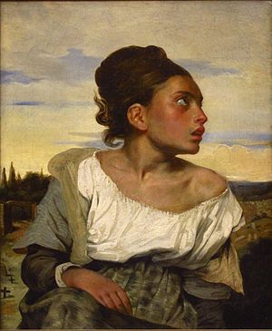

IMAGE 10: Orphan Girl at the Cemetery, Eugène Delacroix (1823-1824)
In this painting, Delacroix depicts a girl, grief-stricken, eyes welling with tears, and looking upward. Behind her there is a dismal landscape, fitting with the vivid depiction of melancholy on her face. Her clothes add to her depiction of sad vulnerability, with her shirt falling off her shoulder and the pale coloring of her dress. For Delacroix, colors were of utmost importance in his paintings. This work was painted only about 2 years before Beethoven’s Op. 135 String Quartet and explores the depiction of tragedy during that time.

Discussion Questions:
- If this work did not include the landscape in the background, would it still depict a similar mood?
- Why do you think the artist depicted the girl looking up?
- How might the introduction to the 4th movement of Beethoven’s Op. 135 be similar to this painting? Think about the words that were included in that movement of Beethoven (The difficult resolution—Must it be?—It must be, it must be!). There is speculation as to what this means, but some might say it is about facing and accepting death or another deep philosophical question.

Song of the River, by Louise Glück
This year, for the Cypress String Quartet’s 17th and final Annual Call & Response program, a brand new composition was written for the quartet by American composer, Dan Coleman. His work is inspired by the idea of tragedy & comedy and Beethoven, and is especially influenced by the following poem by Louise Glück. She often uses Greek & Roman myths as inspiration, adding especially to the tragic impact of her works. However, in many of her poems, she is able to seamlessly weave a shimmer of hope into the tragic fibers of life. Dan Coleman’s new String Quartet No. 3 is entitled “together, as the river”, and is in memory of composer Jeffery Cotton. Cotton was an American composer and wrote his beautiful “Serenade (String Quartet No. 2)” for the CSQ Call & Response program in 2011.

Coleman’s String Quartet No. 3 begins by exploring all pairs of instruments before, well into the piece, we see these “rivers” of instruments collide into one. For example, the beginning starts with a duet between 2 violins, then a trio between 2 violins and cello, then cello and violin, etc. Taking from the words of Louise Glück, “nothing happens twice” and the instruments constantly “drift apart and together” with trees of “cypress” in the landscape.

Once we were happy, we had no memories.
For all the repetition, nothing happened twice.
We were always walking parallel to a river
with no sense of progression
though the trees across from us
were sometimes birch, sometimes cypress-
the sky was blue, a matrix of blue glass.

While, in the river, things were going by-
a few leaves, a child's boat painted red and white,
its sail stained by the water-

As they passed, on the surface we could see ourselves;
we seemed to drift
apart and together, as the river
linked us forever, though up ahead
were other couples, choosing souvenirs

- You will hear this work during the Cypress String Quartet’s concert and visit, but before you hear it, what do you think this piece will sound like?
- MUSICAL EXAMPLE 19: quartetto ricercare, I. Fierce, obsessed by Dan Coleman (Dedicated to the Cypress String Quartet)
This musical example is to give the students a feel for the works of Dan Coleman. This piece was the first commissioned work for the CSQ Call & Response program in 2000.
- If you were to write a work based on this poem, what would it sound like? What musical techniques would you use?

b. Comedy

MUSICAL EXAMPLE 20: Beatles, “I am the Walrus”
This song came from 3 song ideas John Lennon had been working on. Unable to finish each of the 3, he decided to combine them into one, resulting in a song with very odd lyrics including “sitting on a cornflake.” The song incorporates everyday sound inspirations (police sirens, sitting in a garden), lyrics from a playground nursery rhyme, and a poem by Lewis Carroll known as “The Walrus and the Carpenter.” Interestingly, Lennon incorporates a recording of a dramatic reading of Shakespeare’s “King Lear” and includes dramatic scenes of death. The inclusion of this tragic play at the end of this nonsensical song turns Shakespeare’s tragedy into a comical satyr. At the end of the song we hear characters from the play saying the following:
Edgar: I know thee well: a serviceable villain
As duteous to the vices of thy mistress
As badness would desire.
Gloucester: What, is he dead?
Edgar: Sig you down father, rest you

- What makes this song comedic?
- What is the tone of this song? How does it make you feel?
- What musical tools does it use? How does it use sound?
- What effect does the inclusion of a recording of a tragic Shakespeare play have on the song?
The inclusion of the tragic reading is ironic. Adding tragedy to a song so nonsensical makes this even more humorous.

MUSICAL EXAMPLE 21: Haydn String Quartet, Op. 33 No. 2, IV. Presto
Written in 1781, Haydn wrote the 4th movement of this work with a light character. Near the end of this movement Haydn plays jokes on the audience by first including numerous pauses and interruptions, playing tricks with the audience as to when the piece will actually end. It has been said that audiences would erupt in laughter as Haydn aimed to make fun of audiences who never knew where to clap.
- What kind of comedy does Haydn use in this work?
- What musical tools does it use?

In the last words of Beethoven:
“Plaudite, amici, comedia finita est"
("Applaud, my friends, the comedy is over")

Dan Coleman was born in New York City in 1972. He has received commissions and performances from the Dallas Symphony, St. Paul Chamber Orchestra, Utah Symphony, Pacific Northwest Ballet, Orpheus, New York Chamber Symphony, Chamber Music Society of Lincoln Center, and the Cypress String Quartet, among many others. He has received two orchestral premieres in Carnegie Hall, most recently by the American Composers Orchestra for a work The New York Times described as a “lyrical and sweeping essay.” His concert music may be heard on the Albany, Centaur, Crystal, and Summit classical record labels.

Since 1994, when he became the first composer on the roster of Young Concert Artists, Dan has been recognized by his peers with accolades from the American Academy of Arts and Letters, the MacDowell and Yaddo artist colonies, the 2004 Copland House / Sylvia Goldstein Award, the 2003 Indianapolis Symphony / Marilyn K. Glick Composer Award, the 2001 NFMC Beyer Chamber Music Award, the 2001 Symphony in C Award, the 2001 Auros Group for New Music Composer Award, a 2001 Meet The Composer “Music Alive” grant, a 2000 Arizona Commission on the Arts Fellowship, the 1999 American Composers Orchestra Whitaker Commission, the 1999 NYU Tisch School First Run Festival Best Original Film Score, the 1997 Victor Herbert/ASCAP Award, a 1996 Meet The Composer Commissioning USA grant, the 1995 FirstMusic Commission from the New York Youth Symphony, and a 1995 Theodore Presser Award.

Dan has served as resident composer for the Seattle Chamber Music Festival, Music from Angel Fire (NM), and Alpenglow Music Festival (CO). From 1994-99, Dan was the resident composer for the Metamorphosen Chamber Orchestra in Boston. In 2002, Dan was appointed Composer-in-Residence of the Tucson Symphony Orchestra, a post he retains through the 2015-16 season.
Outside of the concert hall, Dan has arranged and conducted music for many acclaimed projects, including all of the albums recorded in the 1990s by songwriter Lisa Loeb on the Atlantic, A&M, Artemis, and Geffen labels. Dan co-wrote and arranged songs for two albums by the band Calexico: Garden Ruin (2006), and Spiritoso (2013). Dan conducted the studio orchestra for jazz pianist Brad Mehldau’s Highway Rider album (2010), and for Jake Shimabukuro’s Grand Ukelele (2012). In 2013, he arranged, conducted, and toured with jazz saxophonist Joshua Redman in support of the album Walking Shadows.

In 2004, Dan co-founded Modern Works Music Publishing, whose first signing was John Legend and whose current roster of popular artists includes Andy Summers (of The Police), Bootsy Collins (Parliament-Funkadelic), contemporary bluegrass icon Alison Krauss, Motown legend Ronnie Spector, multiplatinum record producer Michael Beinhorn (Soundgarden, Korn, Marilyn Manson, Hole), and symphonic composer Michael Torke, among many others. Modern Works Music Publishing’s diverse catalog contains over 30,000 works including classics from the 1950s such as Erroll Garner’s “Misty,” “Bemsha Swing” by Thelonious Monk, the Grammy-winning instrumental “Rockit” by Herbie Hancock, and Skee-Lo’s “I Wish” rap from the 90s.
Dan serves on the Board of Directors of the BMI Foundation and the Tucson Jazz Festival.

[January 2016]
Cypress String Quartet:

In nearly 20 years on the concert stage, the four members of the San Francisco-based Cypress String Quartet (CSQ) have played over 15,000 concerts together throughout North America, Europe, Asia, and Latin America. Praised by Gramophone for their “artistry of uncommon insight and cohesion,” and by the NY Times for “tender, deeply expressive” interpretations, they have recorded over 15 albums and are played regularly on hundreds of radio stations throughout the world. They have also been heard on the Netflix original series "House of Cards" and have collaborated with leading artists ranging from Michael Franti of Spearhead to modern dance companies.

“This young quartet is among the most impressive I have heard in modern sound.“
- Stereophile (reviewing CSQ's “Beethoven: The Late String Quartets”)

Since its inception, the CSQ has created a niche in the world arts community as one of the most passionate, insightful, and innovative ensembles of our time. Whether performing for seasoned concert-goers or people being exposed to classical music for the first time, the CSQ has a unique ability to articulate what is enthralling about the masterpieces they perform.

In addition to definitive interpretations of masters such as Beethoven, Mozart, and Schubert, the CSQ has commissioned works from some of the most important composers of our time including Kevin Puts, Philippe Hersant, Jennifer Higdon, George Tsontakis, and Elena Ruehr.

“The Cypress brought a combination of tenderness and urgency to the music, expertly rendering the piece's delicate weave.” -San Francisco Chronicle (reviewing the world premiere of composer George Tsontakis's String Quartet No.5)

CSQ members were educated at the world’s most prestigious conservatories, including the Juilliard School, the Royal College of Music and Guildhall School of Music and Drama in London, Indiana University-Bloomington, and the Eastman School of Music. Early in their musical careers, the CSQ mentored with members of the Amadeus Quartet in London.

Dedicated to mentoring and training the next generation of exceptionally talented individuals, the CSQ has been visiting artist at Harvard, MIT, Stanford, University of California Berkeley, and other elite universities. The CSQ’s passion for sharing music extends far beyond classroom and concert halls to non-traditional venues such as boardrooms, art galleries, and private residences. By combining passionate performances and lively discussion, the CSQ creates unforgettable experiences for those fortunate enough to participate. At the heart of all CSQ residencies is the belief that music enriches learning and living.

The members of the Cypress Quartet play exceptional instruments including violins by Antonio Stradivari (1681) and Carlos Bergonzi (1733), a viola by Vittorio Bellarosa (1947), and a cello by Hieronymus Amati II (1701). The Cypress Quartet takes its name from the set of twelve love songs for string quartet, Cypresses, by Antonin Dvořák.

Contact Information
44 Page Street, Suite 400
San Francisco, CA 94102
(415) 500-2150
www.cypressquartet.com
csq@cypressquartet.com

